EEZ project – Shortcuts
Shortcuts can simplify execution of SCPI commands sequence or JavaScript code used in communication with an instrument. Shortcuts included into IEXT will become available by default to all instances of the installed instrument and they can be complemented with shortcuts that user defined for selected instrument instance. IEXT project shortcuts section is shown on Fig. 1.

The Add Shortcut option will open an entry form (Fig. 2.) with the following parameters (mandatory parameters are marked bold):
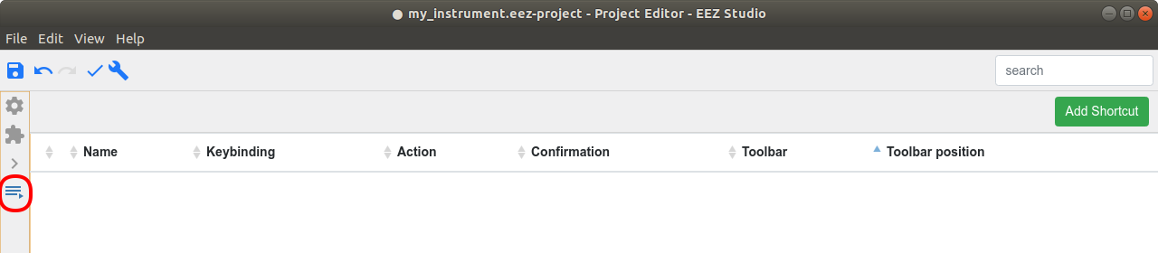Fig. 1: Shortcut and scripts menu

Parameter | Explanation
Name | Shortcut name that will appear in the instrument's shortcut toolbar
Used in | Define build configurations that will include this SCPI command or query. All build configurations option is selected by default.
Keybinding | Shortcut's “hotkey” definition. Usually the function keys are used (F1 to F12) but other combinations with special keys (Ctrl, Alt, etc.) is also allowed.
Action type | Shortcut type: SCPI commands or JavaScript code.
Action code | Contain SCPI commands sequence or JavaScript code depending of selected Action type.
Requires confirmation | When selected, an additional confirmation dialog box will be displayed when shortcut is selected from the instrument's shortcut toolbar.
Show in toolbar | Enable displaying of shortcut button in the instruments shortcut's toolbar
Button position | Shortcut button position within the toolbar. Applicable only if Show in toolbar option is checked.
Button color | Shortcut button color. Applicable only if Show in toolbar option is checked.

An example of a shortcut that include JavaScript code is shown on Fig. 3. Note that its Action type parameter is set to JavaScript.

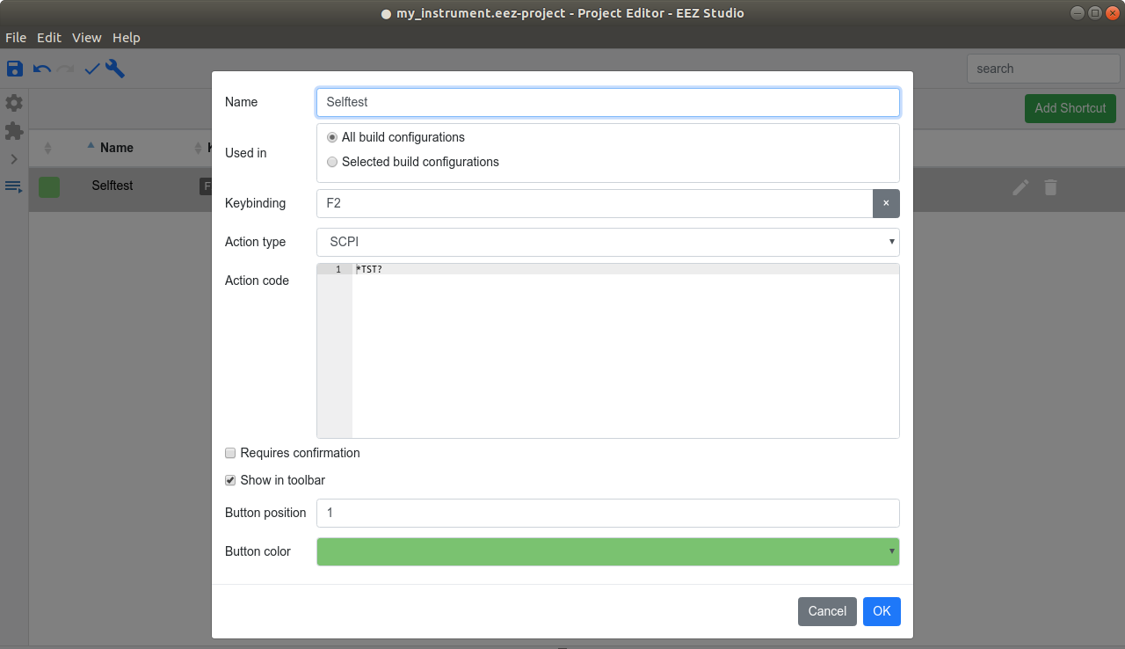Fig. 2: Add new shortcut with SCPI commands sequence
Created shortcut examples will appear in the Shortcut section as shown on Fig. 4. and sorted by their Toolbar position parameter.
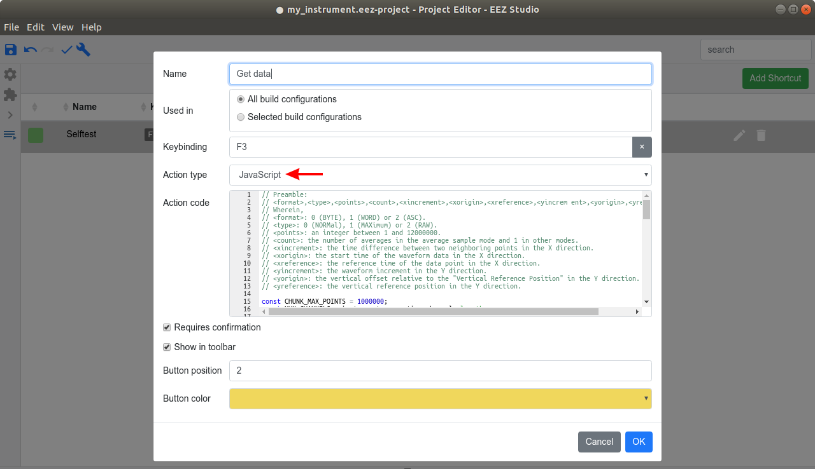Fig. 3: Add new shortcut with JavaScript

Created IEXT's shortcut will appear in the instrument's Terminal and can be accessed by mouse click and F2 and F3 key respectively.
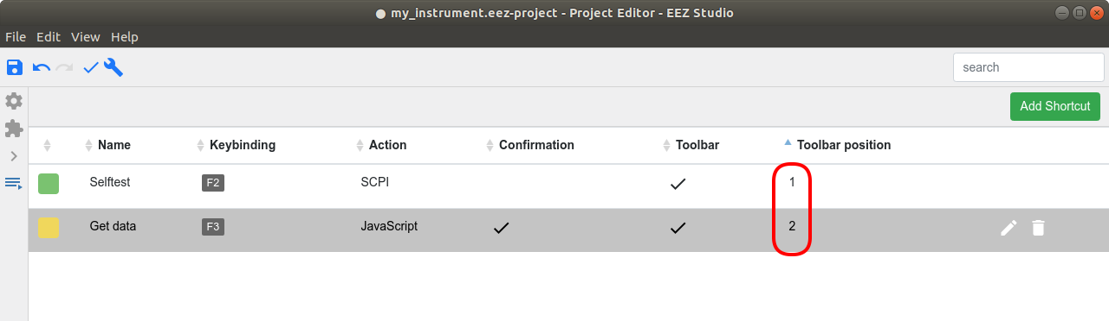Fig. 4: Shortcut's toolbar positions

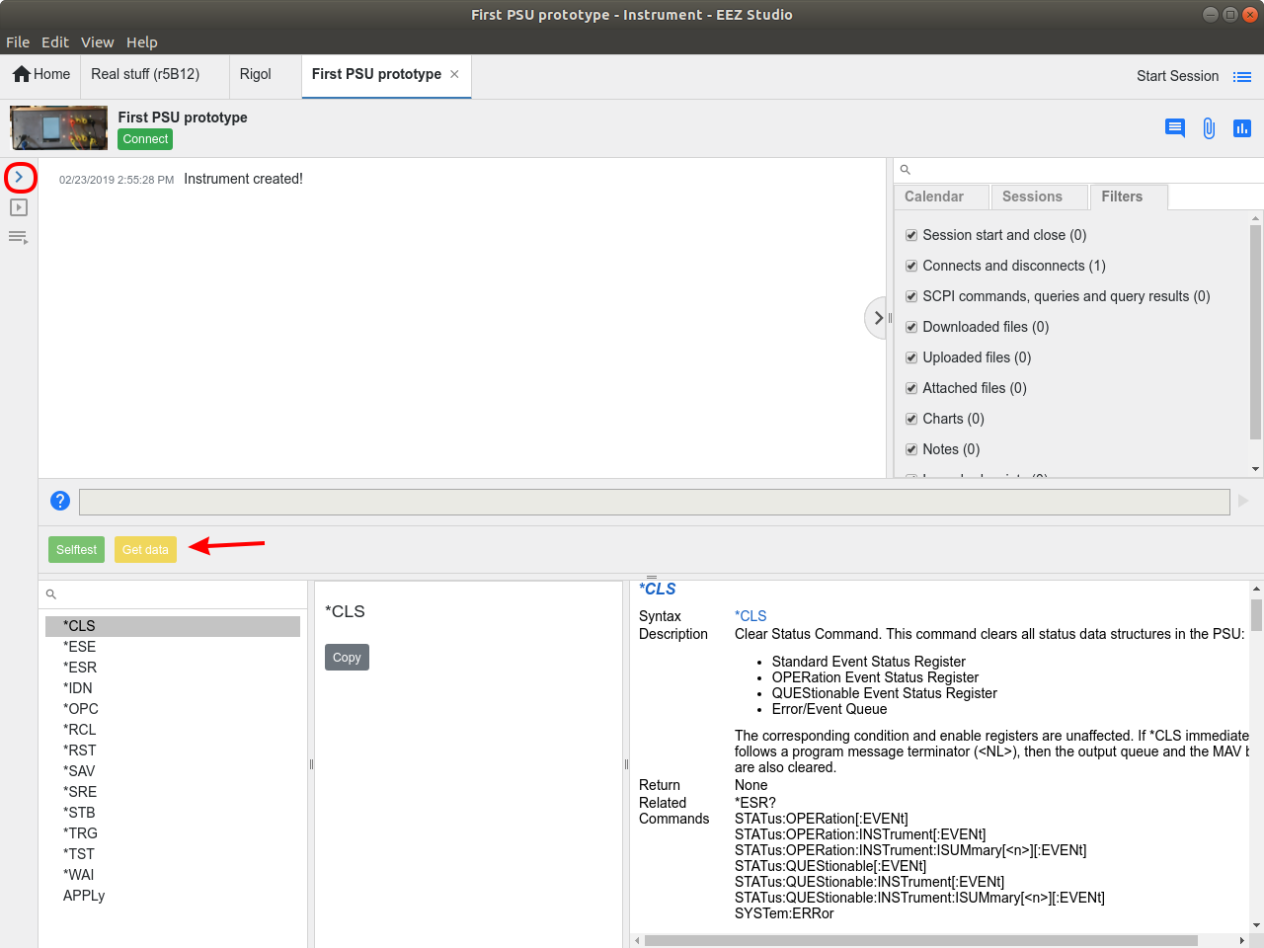Fig. 5: Shortcuts in the instrument toolbar

